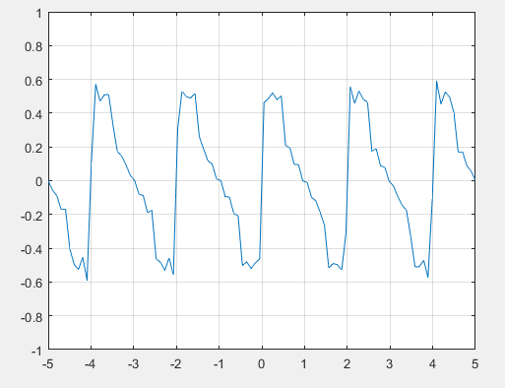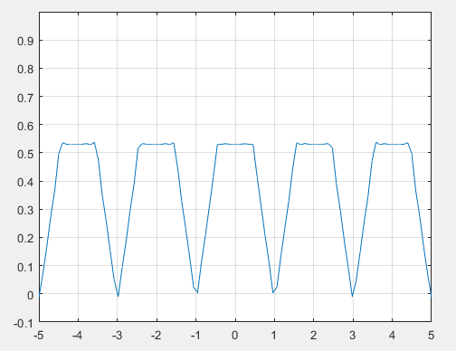Odd Even

Code

x=linspace(-5,5);

n=1:10;

%cos part i.e. even function

%c,d, are just to break it apart into multiple statements

a=3/8;

c=cos((pi/2).\*n)./((pi^2).\*(n.^2));

d=cos(pi.\*n)./((pi^2).\*(n.^2));

an=2\*(c-d);

yc=a+an\*cos(n'\*x\*pi);

plot(x,yc);

axis([-5 5 -0.2 1]);

%Sin Part (I.E. Odd function)

%sb, sc, sp to shorten bn

sb=sin((pi/2).\*n)./(pi^2.\*n.^2);

sc=(cos((pi/2).\*n)./(2\*pi.\*n));

sp=1./(pi.\*n);

bn=sb-sc+sp;

ys=bn\*sin(n'\*x\*pi);

plot(x,ys);

grid on

axis([-5 5 -1 1]);